- In what era is the film set?
- 1900 AD
- 2009
- 1800 AD

- Where was it set ?
- New Zealand
- England
- France

- What word best summed up Frederic Ozanam ?
- Hope
- Optomistic
- Crazy

- Frederic Ozanam believed he could make a …….

- He believed that two important things could make the new world a just world
- They were
- Reform and change
- Faith and ChristianIty
- lots of money and a credit card

- Frederic Ozanam was part of a University
- Debating society debating the conflict between Christianity and progress
- Rock band
- Line Dancing Group

Growing up fast in Paris
It was out of this that the Conference of History was formed. Later to become the Society of St Vincent de Paul
- Sister Rosalie was an important influence on Frederic and his friends . She was the Mother Theresa of that day and worked for the poorest of the poor.

She told Frederic and his friends to do two things….
- Run and hide
- Be kind and love
- Look both ways before crossing the road and remember to brush your teeth

- What age were the men who first started the St Vincent de Paul Society.
- 60 years and older
- 25-59 years
- 23 years of age or younger

- When you meet the poor, you meet…….

- By the time the last of the founders died there were how many conferences.
- 1 or 2
- 100
- 7 thousand

- How many countries were these conferences in ?
- Only France
- Over 30 countrIes
- France and New Zealand
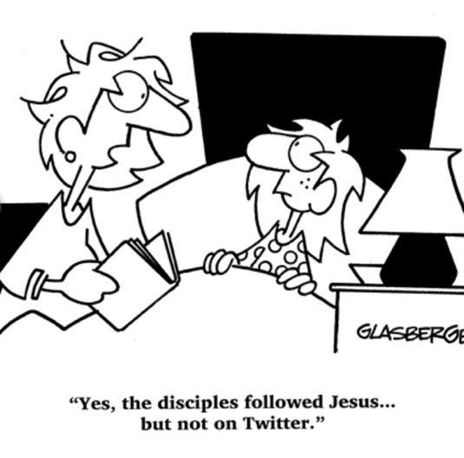
Other things on his mind
- Charity is not enough to solve problems there must be
- Justice
- Hope
- Big dreams

- In the era the film was set, the Society had how many members in Paris alone ?
- 1 or 2
- 2000
- Quite a few

- How many families did the Society support ?
- 1 in 4 families
- 1 in 10 families
- 1 in 100 families

- In 1848 the Revolution swept through France . Frederic Ozanam printed a paper. Name 2 of the things that it called for..
- 1)
- 2)

- Circle the correct statement
- The Church spoke out on social issues
- The Church became silent on social issues

No time like now
- By Frederic Ozanam's 39th birthday there was how many members of St Vincent de Paul ?
- Only Frederic's friends
- 2000
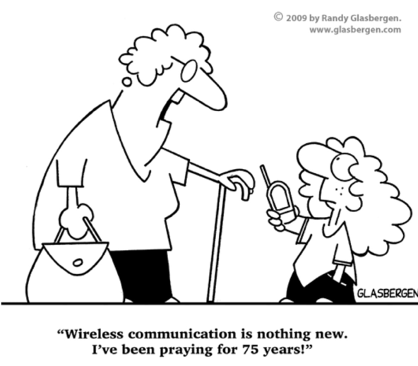
- Forty thousand

- In which countries or parts of the world did the St Vincent de Paul Society now operate in ?

- Frederic Ozanam was one of the strongest voices for Social Reform in the French Church.How old was he when he died ?
- really old
- Is he dead?
- 40

- What did Frederic Ozanam encourage his friends to do ?
- Live life to the max
- Eat their their vegetables
- Act

Today
- How many countries is St Vincent de Paul in today?

- When was Frederic Ozanam beatified?

- The quote from Frederic Ozanam reads .

